

**Submitted by:** Maryam Bibi

## **Reg #:** fa21-bcs-047

**Launch an Amazon EC2 Instance for Apache Server**:

Launch a new EC2 instance from the AWS management console. Select the required instance type and configure the instance as needed.

**Access the EC2 Instance**:  
Once the EC2 instance is running, use SSH to access it. Open a terminal and type:  
ssh -i /path/to/your-key.pem ubuntu@<EC2-public-IP>

**Install Apache on the EC2 Instance**:

* Update the system by running:  
  sudo apt update
* Install Apache by running:  
  sudo apt install apache2 -y

**Verify Apache Server**:  
Open a web browser and enter the public IP of your EC2 instance:  
<http://<ec2-public-ip>/>

<http://13.61.148.199/>

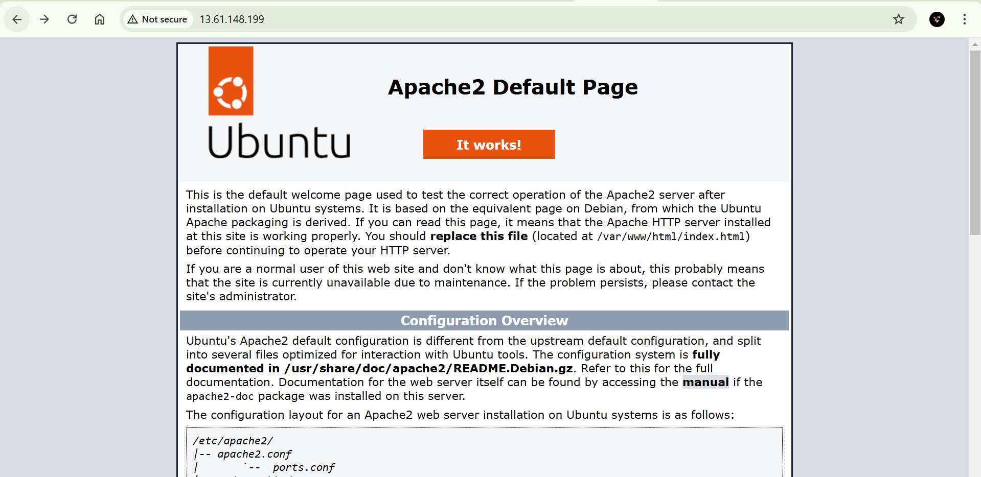

### ****Setting Up Jenkins (EC2 Instance)****

**Launch an Amazon EC2 Instance for Jenkins**:  
Launch a new EC2 instance from the AWS management console.

**Connect the Jenkins Instance :**  Select thhe instance and press connect

### **Installation of Java**

sudo apt update

sudo apt install fontconfig openjdk-17-jre

java -version

### **Installation of Jenkins**

sudo wget -O /usr/share/keyrings/jenkins-keyring.asc \

https://pkg.jenkins.io/debian-stable/jenkins.io-2023.key

echo "deb [signed-by=/usr/share/keyrings/jenkins-keyring.asc]" \

https://pkg.jenkins.io/debian-stable binary/ | sudo tee \

/etc/apt/sources.list.d/jenkins.list > /dev/null

sudo apt-get update

sudo apt-get install jenkins

**Acces jenkins on web page:**

http://<your-jenkins-ec2-public-ip>:8080

<http://13.61.104.159:8080/>

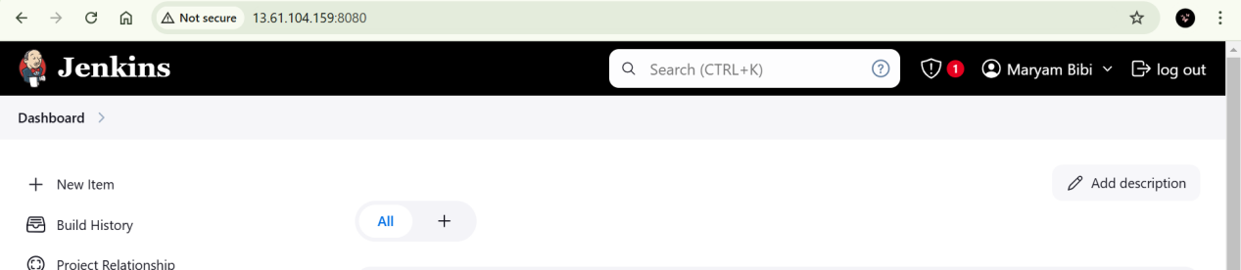

**Instances in EC2 console:**

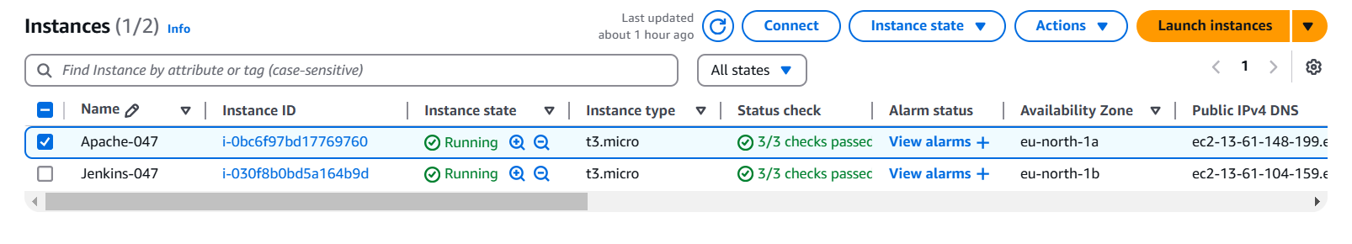

**Install Suggested Plugins**:

* ssh-agent
* Webhook plugin
* Multibranch pipeline

### ****Set Up Jenkins Credentials****

1. **Add SSH Key Credentials**:
   1. In Jenkins, go to **Manage Jenkins > Manage Credentials**.
   2. Click on **(global) > Add Credentials**.
   3. Select **SSH Username with private key**.
   4. Enter ubuntu as the username and paste the private key generated for the Apache server.
   5. Click **OK** to save the credentials.

### ****Setting Up GitHub Repository and Webhook****

**Create a GitHub Repository**:  
Create a repository on GitHub and push your project files.

**Create 2 Branches in the Repository**:

* 1. **Branch1**
  2. **main**

**Jenkinsfile**:  
In both branches, create a Jenkinsfile that defines the pipeline.

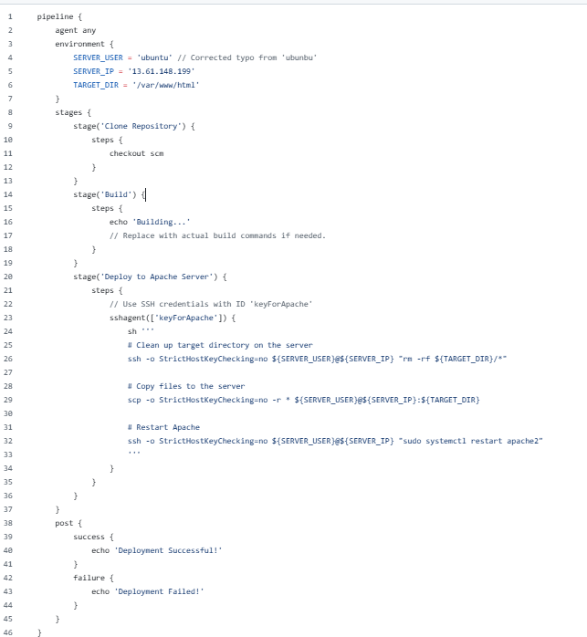Additionally, create an HTML file in each branch for testing the deployment.

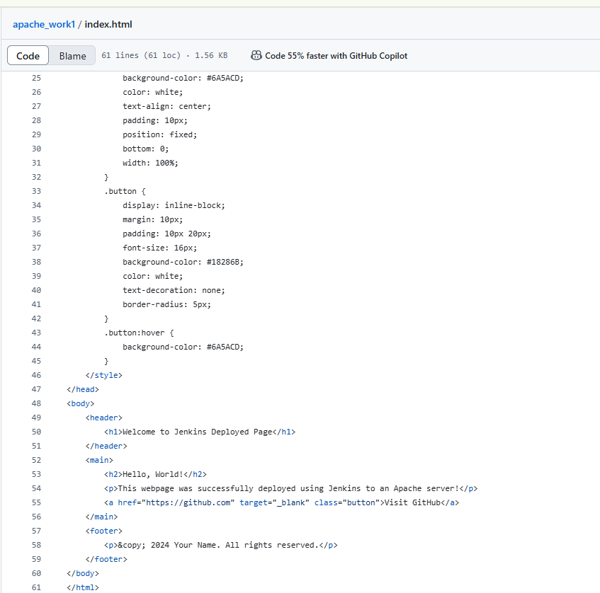

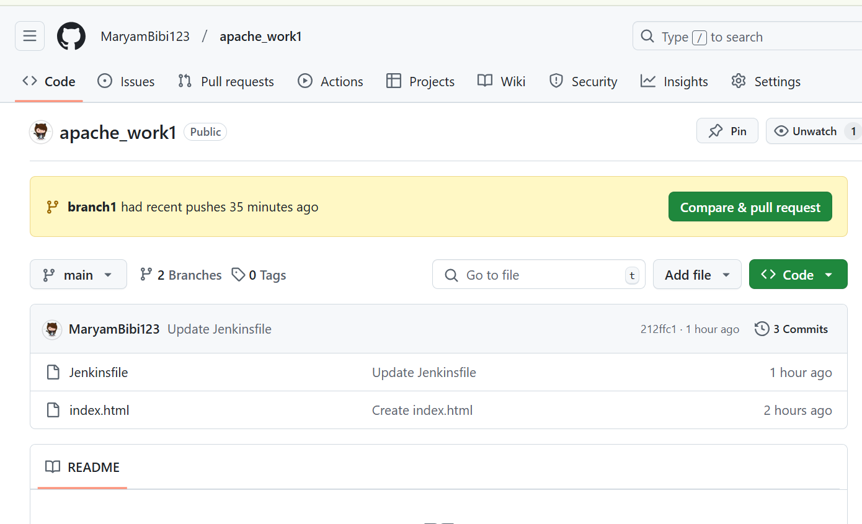

**Set Up Webhook for Jenkins**:

In your GitHub repository, go to **Settings > Webhooks** and click on **Add webhook**.

* 1. In the **Payload URL**, enter your Jenkins server URL followed by /github-webhook/ (e.g., http://<Jenkins-IP>:8080/github-webhook/).
  2. Set the **Content type** to application/json.
  3. Choose the **Just the push event** option.
  4. Click **Add webhook**.

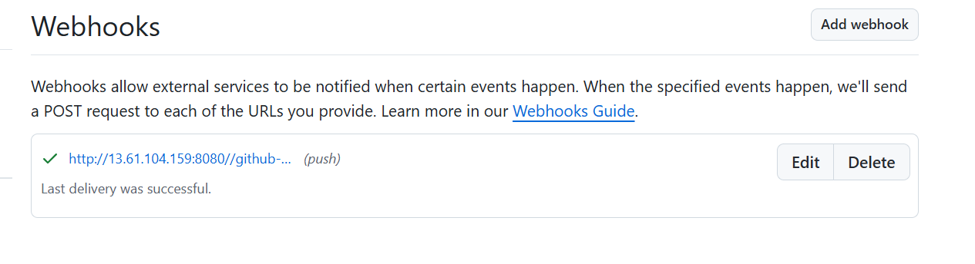

### ****Configure Jenkins Job****

**Create a New Jenkins Pipeline**:

* 1. Go to the Jenkins Dashboard and click on **New Item**.
  2. Select **Multibranch Pipeline**, provide a name (e.g., Assignment4), and click **OK**.

**Add Branch Source**:

* 1. Choose **Git** as the branch source.
  2. Enter the URL of the GitHub repository (e.g., https://github.com/MaryamBibi123/apache_work1.git
  3. Under **Credentials**, select the credentials created earlier for GitHub.

**Save and Build**:

* 1. Click **Save**.
  2. Trigger the build by clicking **Build Now**.

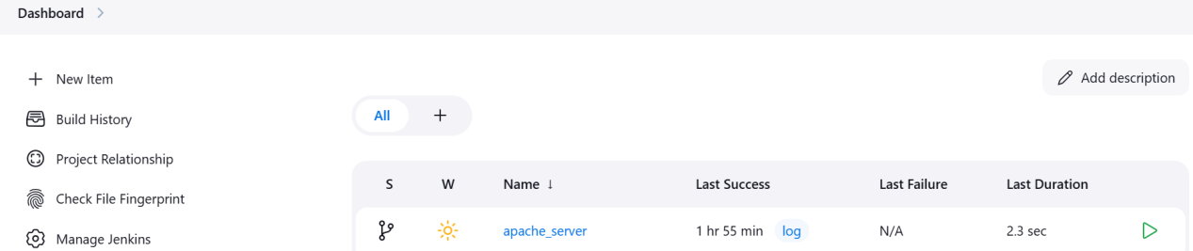

**Builds:**

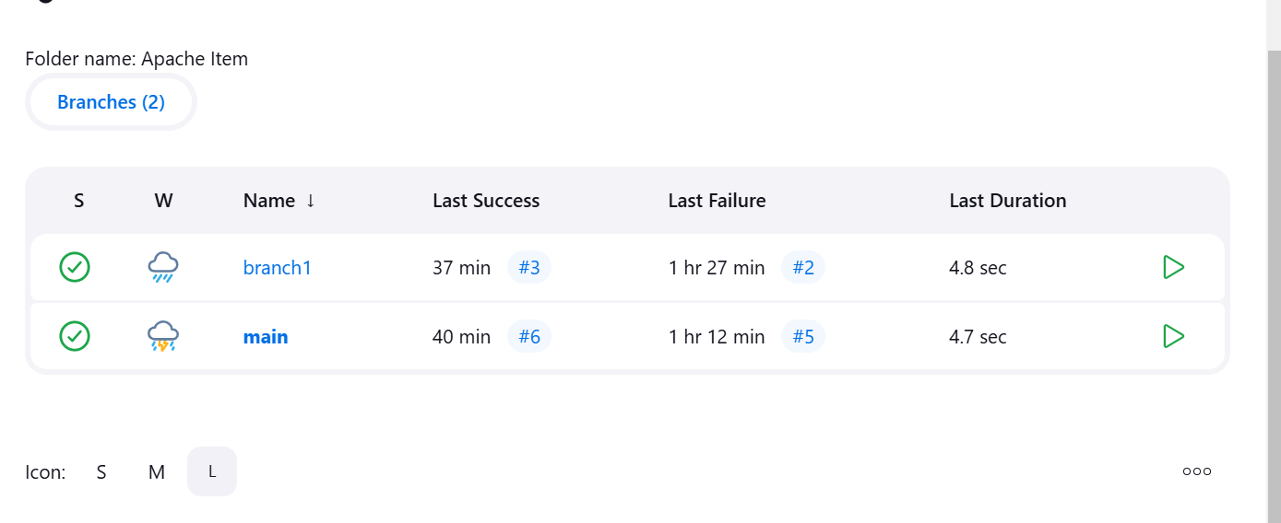

# Verify Deployment

1. **Access the Apache Server**:
   * Open a web browser and navigate to:
   * <http://13.61.148.199/index.html>

